Group: 6

Member:

|  |  |
| --- | --- |
| Student1032633 | NGUYEN HUU DAM |
| Student1040277 | TO NGUYEN THIEN CHI |
| Student1048374 | DINH HOANG QUAN |

**I. Architecture & Design of the Project**

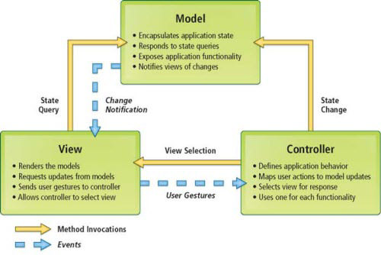

***1. Presentation Tier:***

Is the tier in which the users interact with application . Presentation Tier contents Model, View, Controller used to receive a request and response to User.

Technology: ASP.NET MVC5, HTML, CSS, JavaScript, Ajax, JQUERY, Bootstrap

***2. Business Logic Tier:***

Is mainly working as the bridge between Data Tier and Presentation Tier. All the Data passes through the Business Tier before passing to the Presentation Tier.

Technology: OOP, ASP.NET

***3. Data Access Tier:***

Is basically the server which stores all the application’s data .Data tier contents Database Tables, Database Views and other means of storing Application Data .

Technology: SQL Server, LINQ, ADO.NET

**II. Algorithms - Data Flowchart:**

**Dam dm mat zaiii**

**III. Data Flow Diagram:**

**Chi**

**IV. Use Case Diagram:**

**Chi**

**V. Sequence Diagram:**

**Dam**

**VI. Entity–Relationship Design:**

**Quan**

**VII. Task sheet review 2**